Part 1:-

## 1- In your own words, what are ping, tracert, nslookup (write one sentence for each one)

Ping: is a tool used to test the reachability of a host on an Internet Protocol (IP) network and to measure the round-trip time for messages sent from the originating host to a destination computer.

Tracert**:** is a tool that helps determine the path taken by packets across an IP network from the host machine to the target device.

Nslookup**:** is a command-line tool used to query the Domain Name System (DNS) to obtain domain name or IP address mapping or any other specific DNS record.

## Ping a device in the same network, e.g. from a laptop to a smartphone

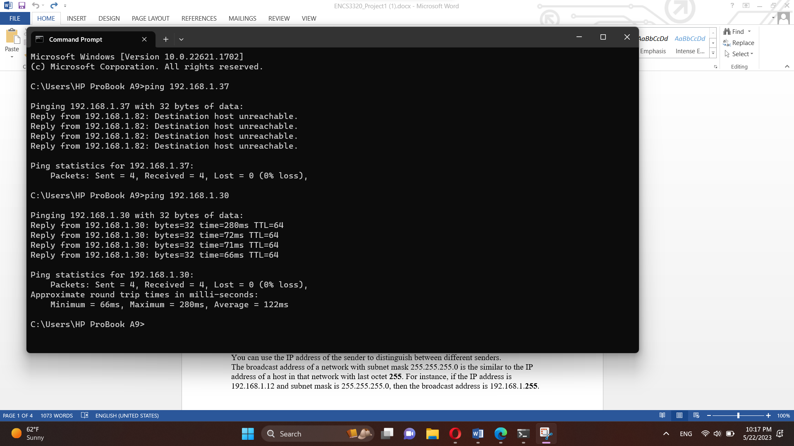

The first four lines show the response to each of the four requests, including the time it took for the device to respond (in milliseconds). The "TTL" value stands for "Time to Live" and refers to the number of hops that a packet is allowed to pass through before it is discarded.

The final section shows a summary of the ping results. It indicates that all four packets were sent and received successfully. It also provides some statistics on the round-trip time of the packets.

## 2- ping www.harvard.edu

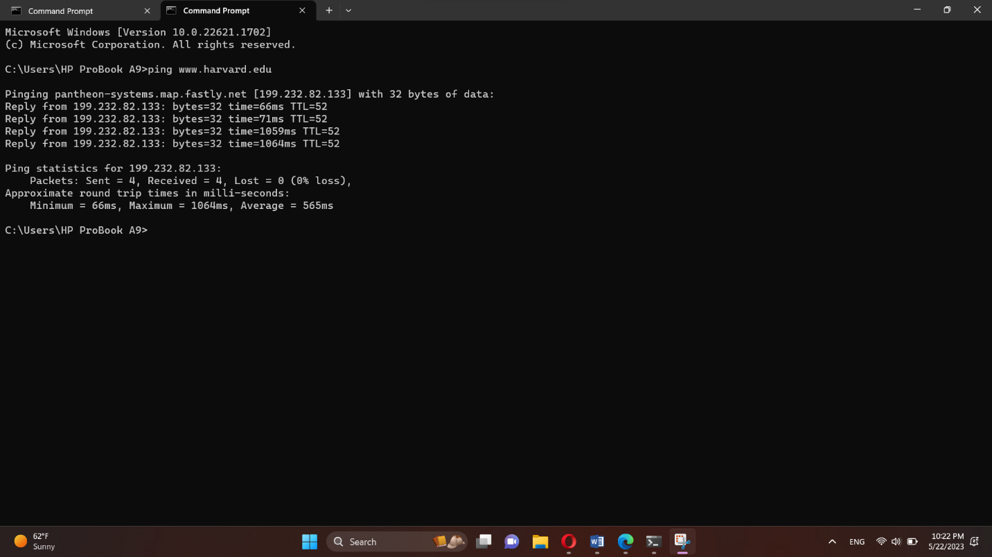

“www.harvard.edu” is just an alias; as we can see when we run this command “ping www.harvard.edu” a message has been appeared “Pinging pantheon-systems.map.fastly.net” and not “Pinging www.harvard.edu”, that is because “www.harvard.edu” is just an alias of “Pinging pantheon-systems.map.fastly.net”. 199.232.82.133 is the IP address of “pantheon-systems.map.fastly.net”. You can see a reply from the destination and that indicates that the name resolution by DNS is working fine.

## 3-tracert www.harvard.edu

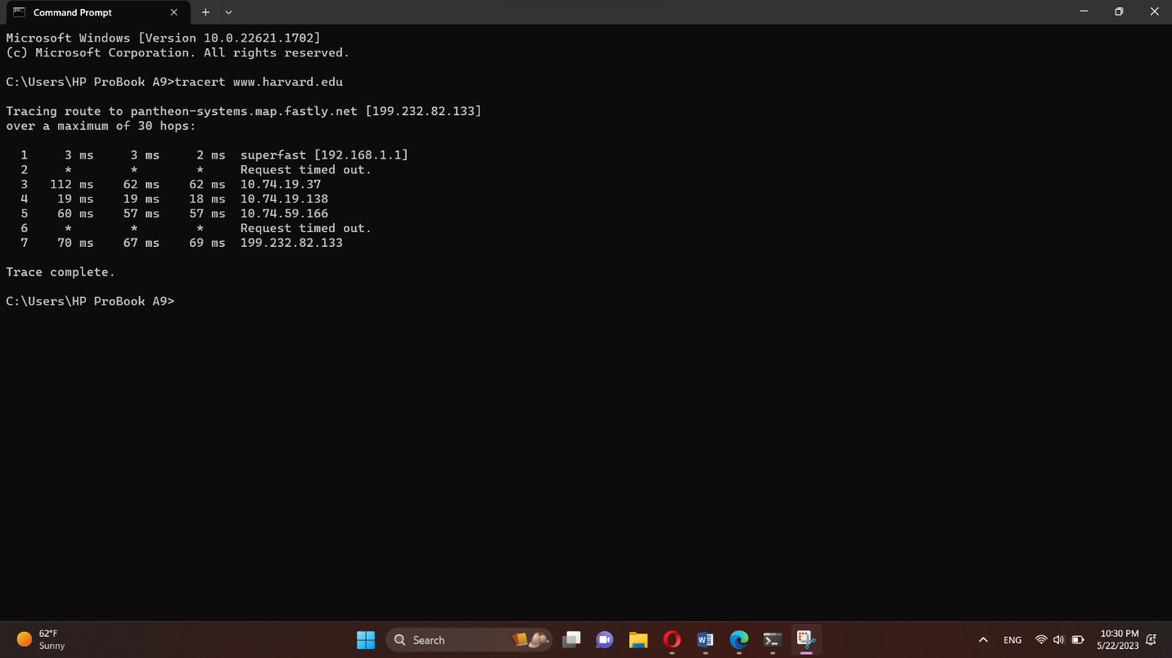

The data packets will find its way to the destination www.harvard.edu and each time it reach a router on its path it will report back information about that router (The IP address and the time it took between each hop) The message “Over a maximum of 30 hops” : if you hit more than 30 routers to reach the destination the tracert command will stops at the 30 hop, so the maximum amount of hops you can trace by default is set to be 30 (you can use “trace -h” to change the number of hops you want to travel) . The first column from the left represents the number of the hop along the route the final router (or hop) number is 7 so it took 7 routers (7 hops) for my device to reach the destination “www.harvard.edu”. The tracert (Trace Route) sends three separate signal packets, so the second, third and fourth columns are the RTT of the three packets.

## 4-tracert www.harvard.edu

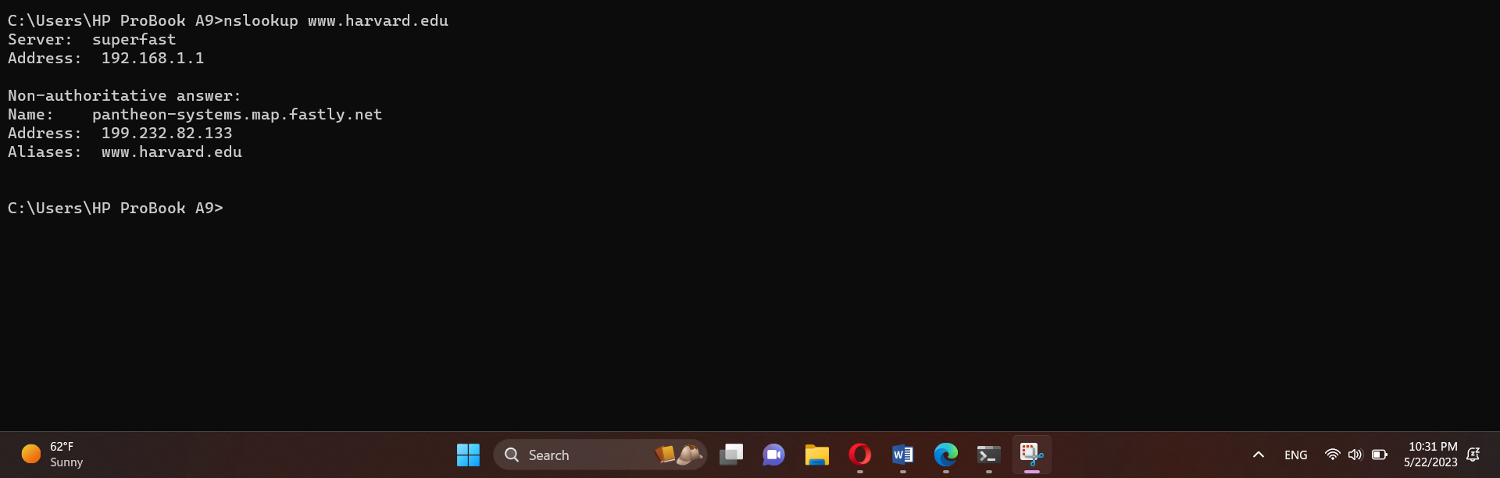

The DNS server returned the name “pantheon-systems.map.fastly.net” as well as a list of IP addresses and aliases associated with the domain “www.yale.edu”. These IP addresses and aliases can be used to access the website or other resources associated with the domain.

The “Non-authoritative answer” message indicates that the DNS server being used is not the authoritative source of information for the domain “www.yale.edu”.

# **Part3:**

## 1- if the request is **/ or /index.html or /main_en.html or /en (for example localhost:9977/ or localhost:9977/en)** then the server should send main_en.html file with Content-Type: text/html.

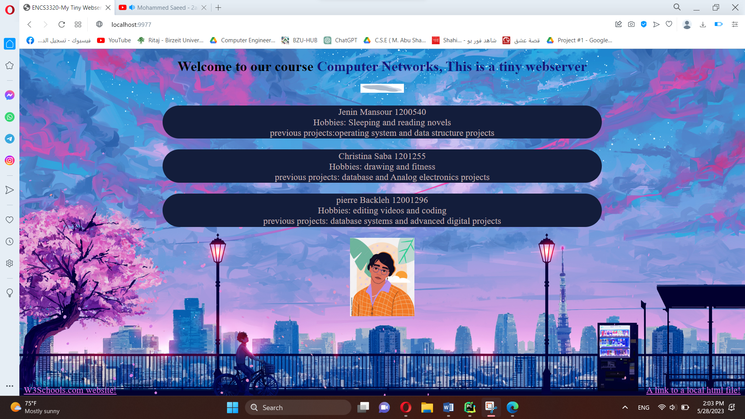

/main_en.html:

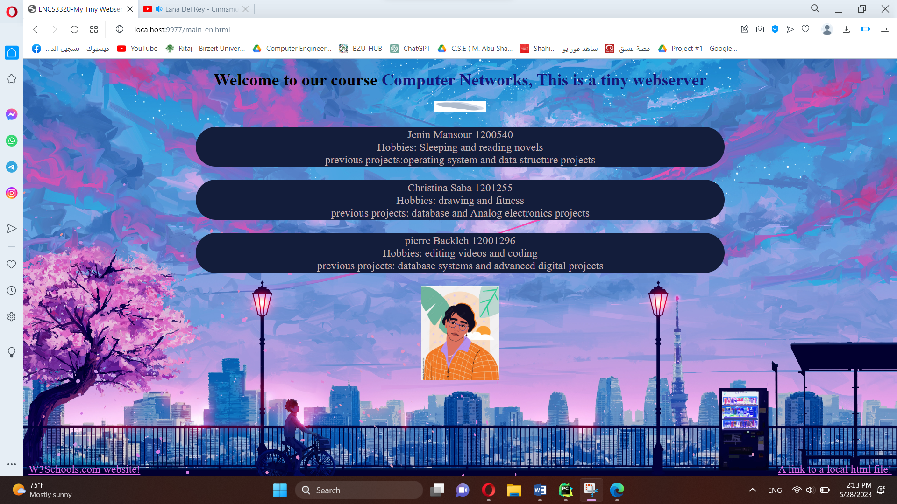

Link to html file

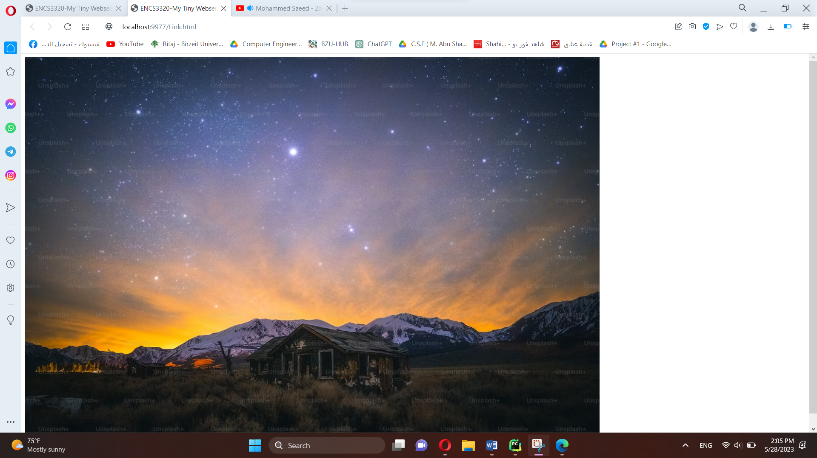

www3 website

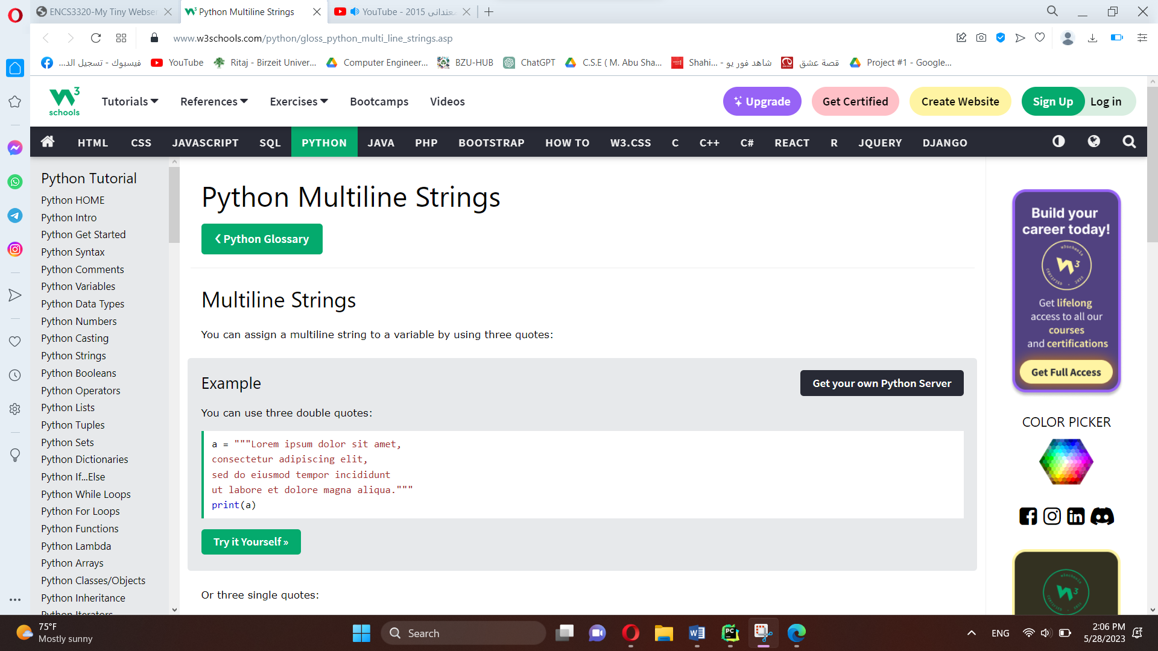

## 2- If the request is /ar then the server response with main_ar.html which is an Arabic version of main_en.html

## 

## 3-if the request is an .**html** file then the server should send the requested html file with Content-Type: text/html

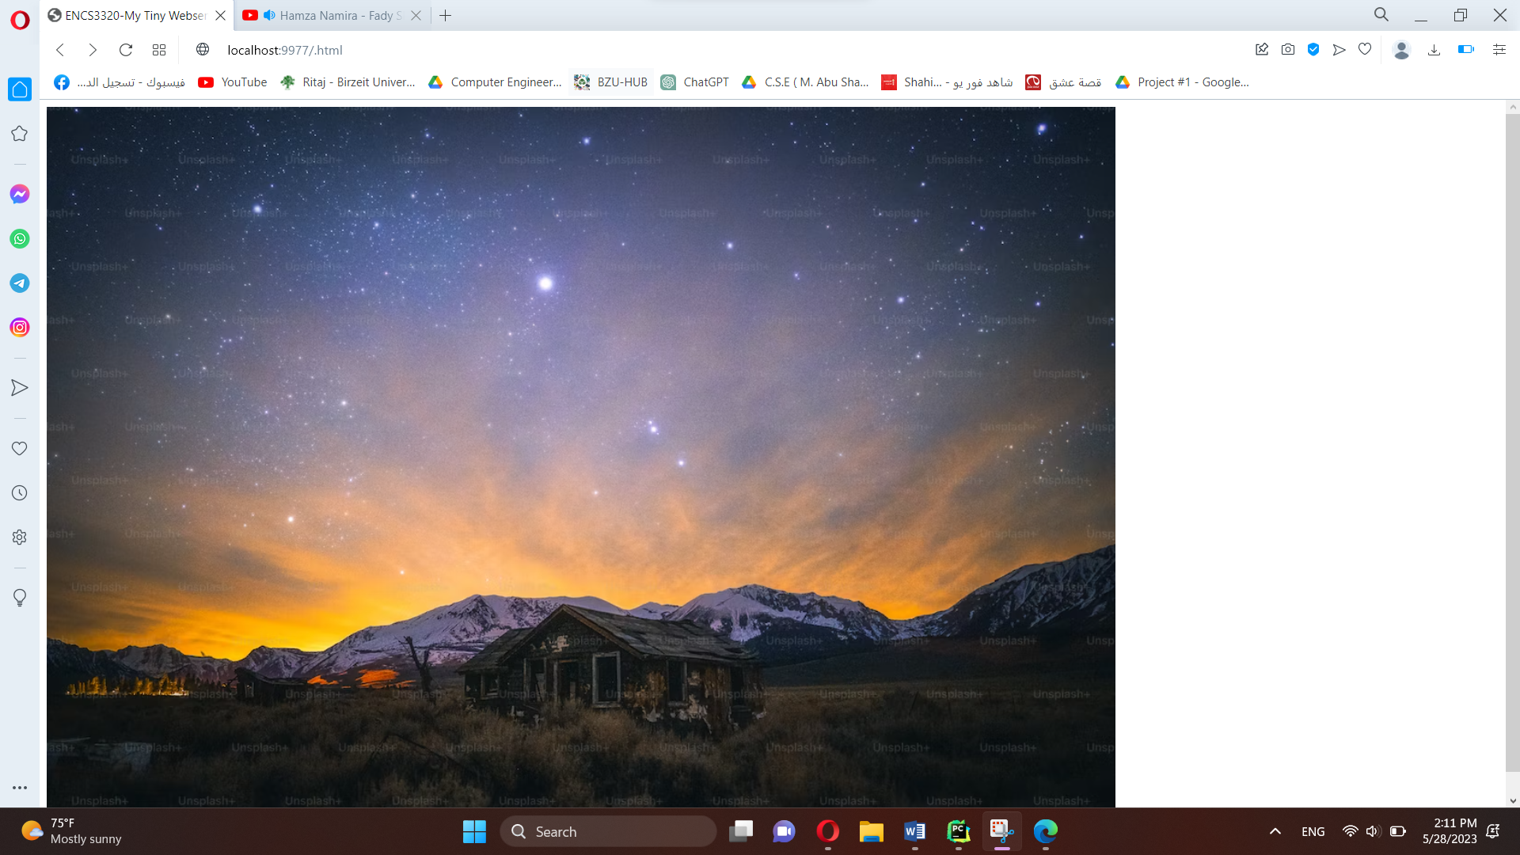

## 4-if the request is a **.css** file then the server should send the requested css file with Content-Type: text/css. You can use any CSS file

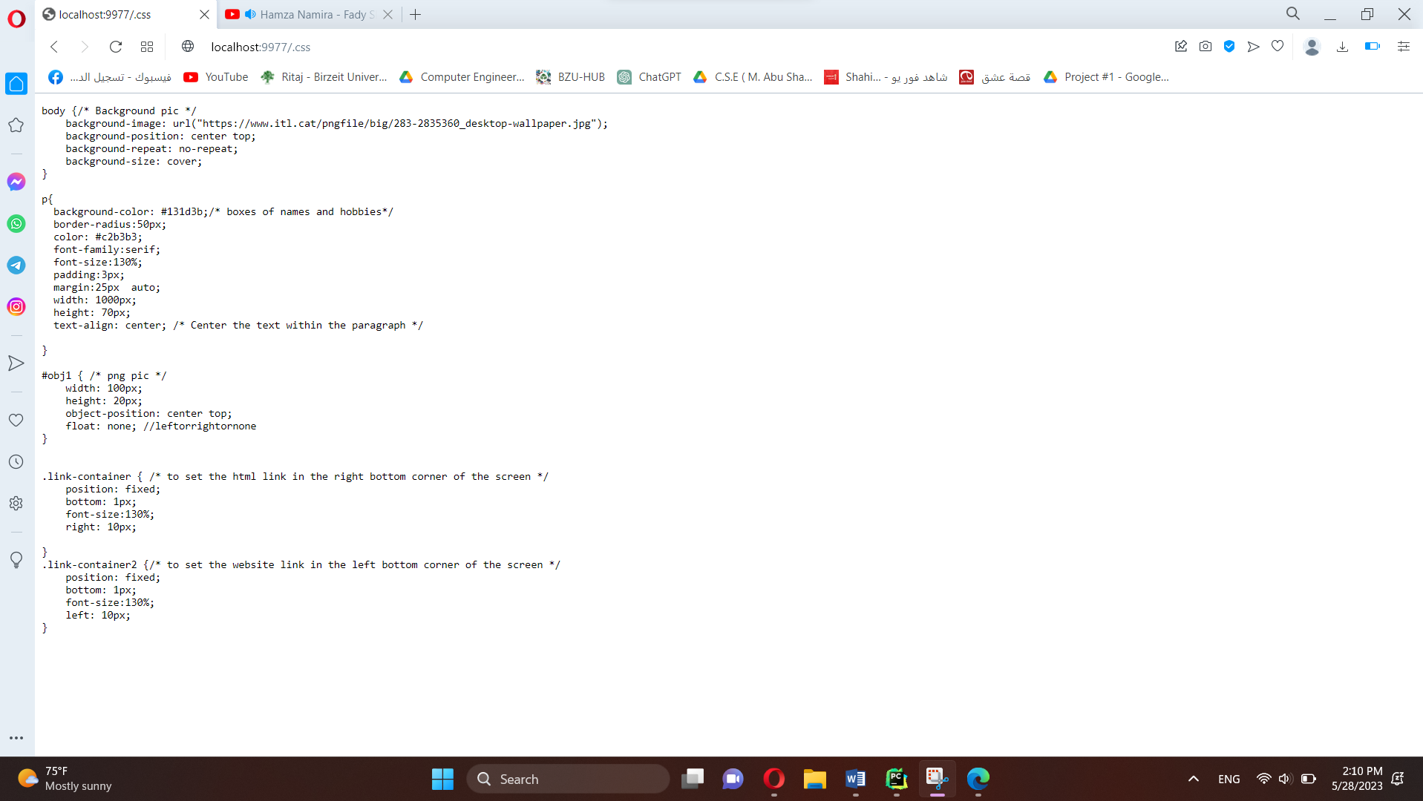

## 5-if the request is a .**png** then the server should send the png image with Content- Type: image/png. You can use any image.



## 6-if the request is **.jpg** then the server should send the jpg image with Content-Type: image/jpeg. You can use any image.

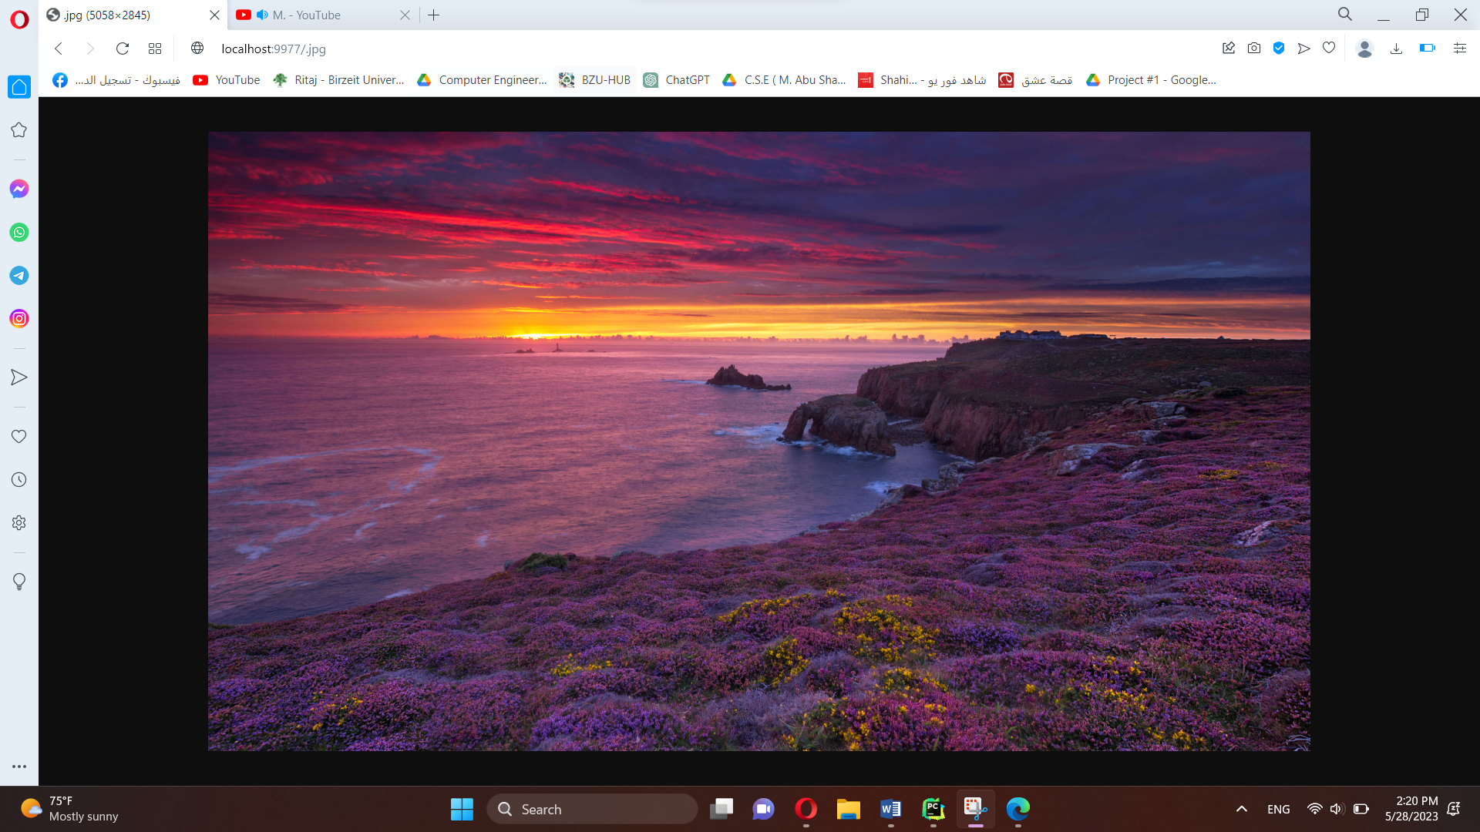

# 7-Use the status code 307 Temporary Redirect to redirect the following

If the request is /yt then redirect to youtube website



If the request is /so then redirect to stackoverflow.com website



If the request is /rt then redirect to ritaj website



## 8-If the request is wrong or the file doesn’t exist the server should return a simple HTML webpage that contains (Content-Type: text/html)

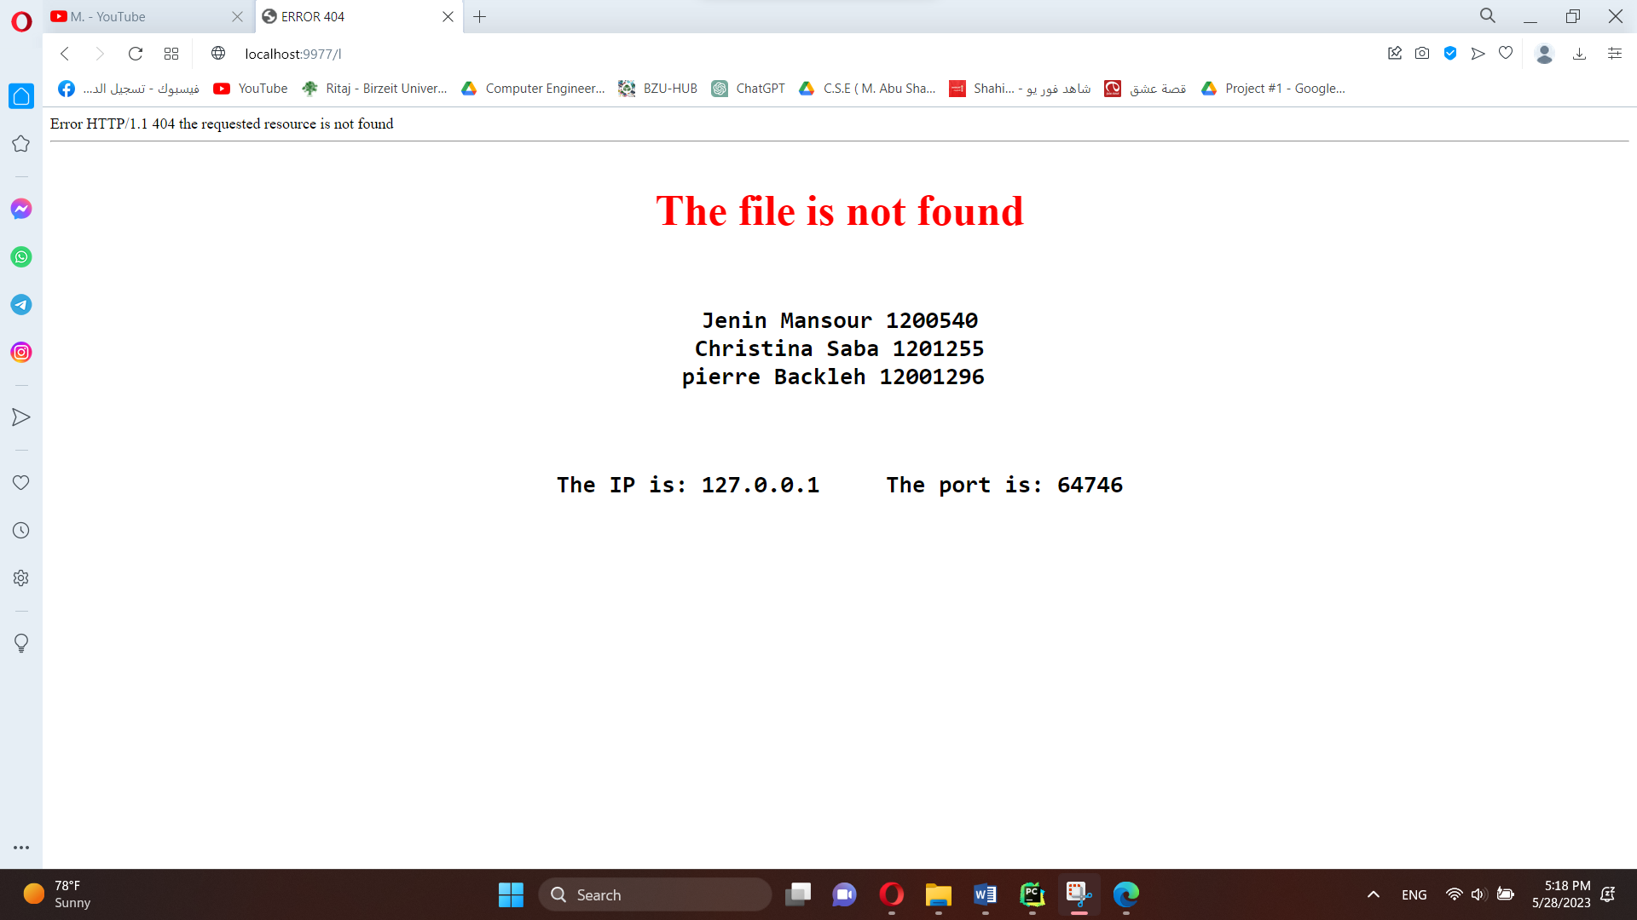

## 9-The program should print the HTTP requests on the terminal window (command line window).

## 10- Screenshots from other device

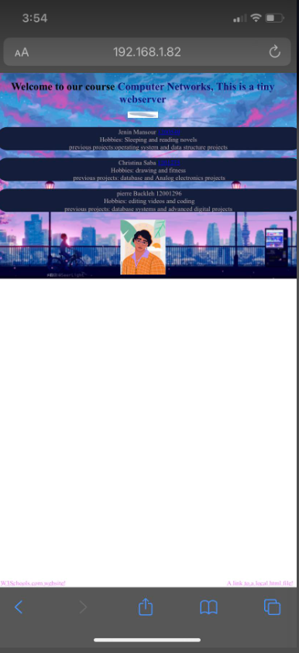 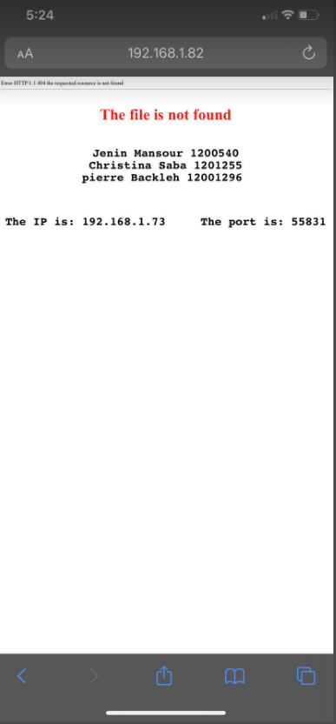

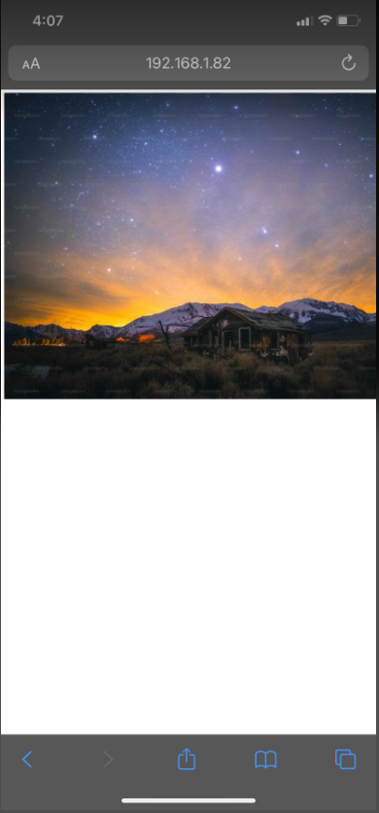 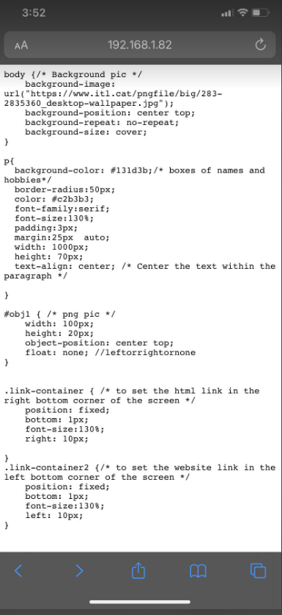

Terminal on the same computer

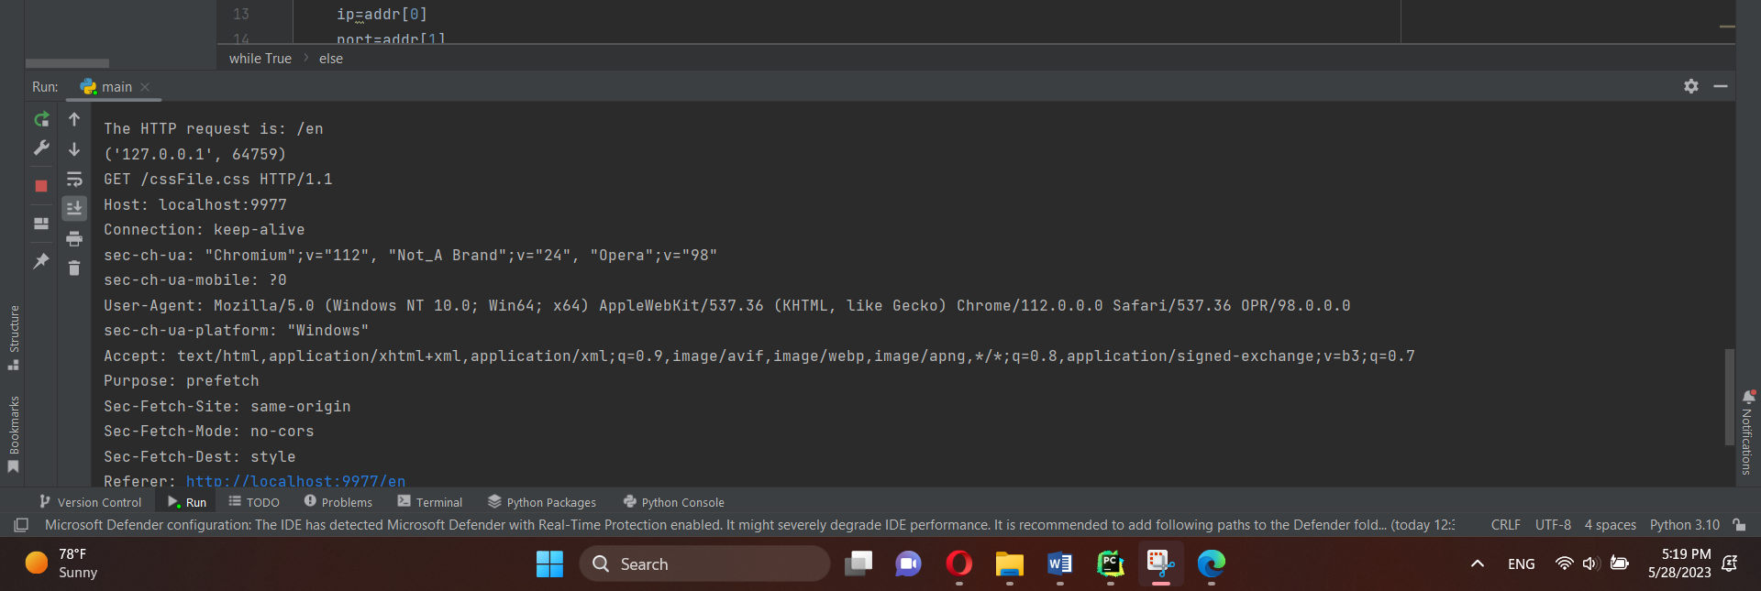

Other device

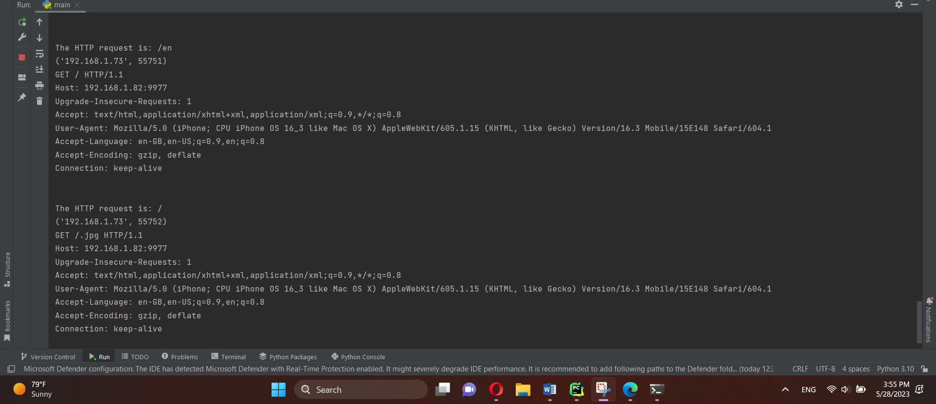

cssFile

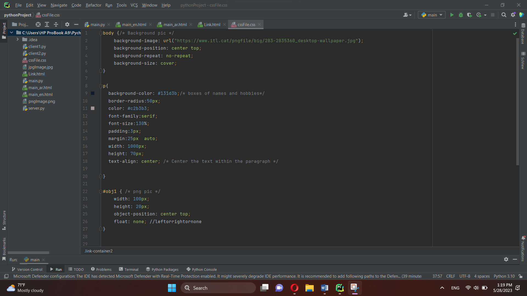

main_en.html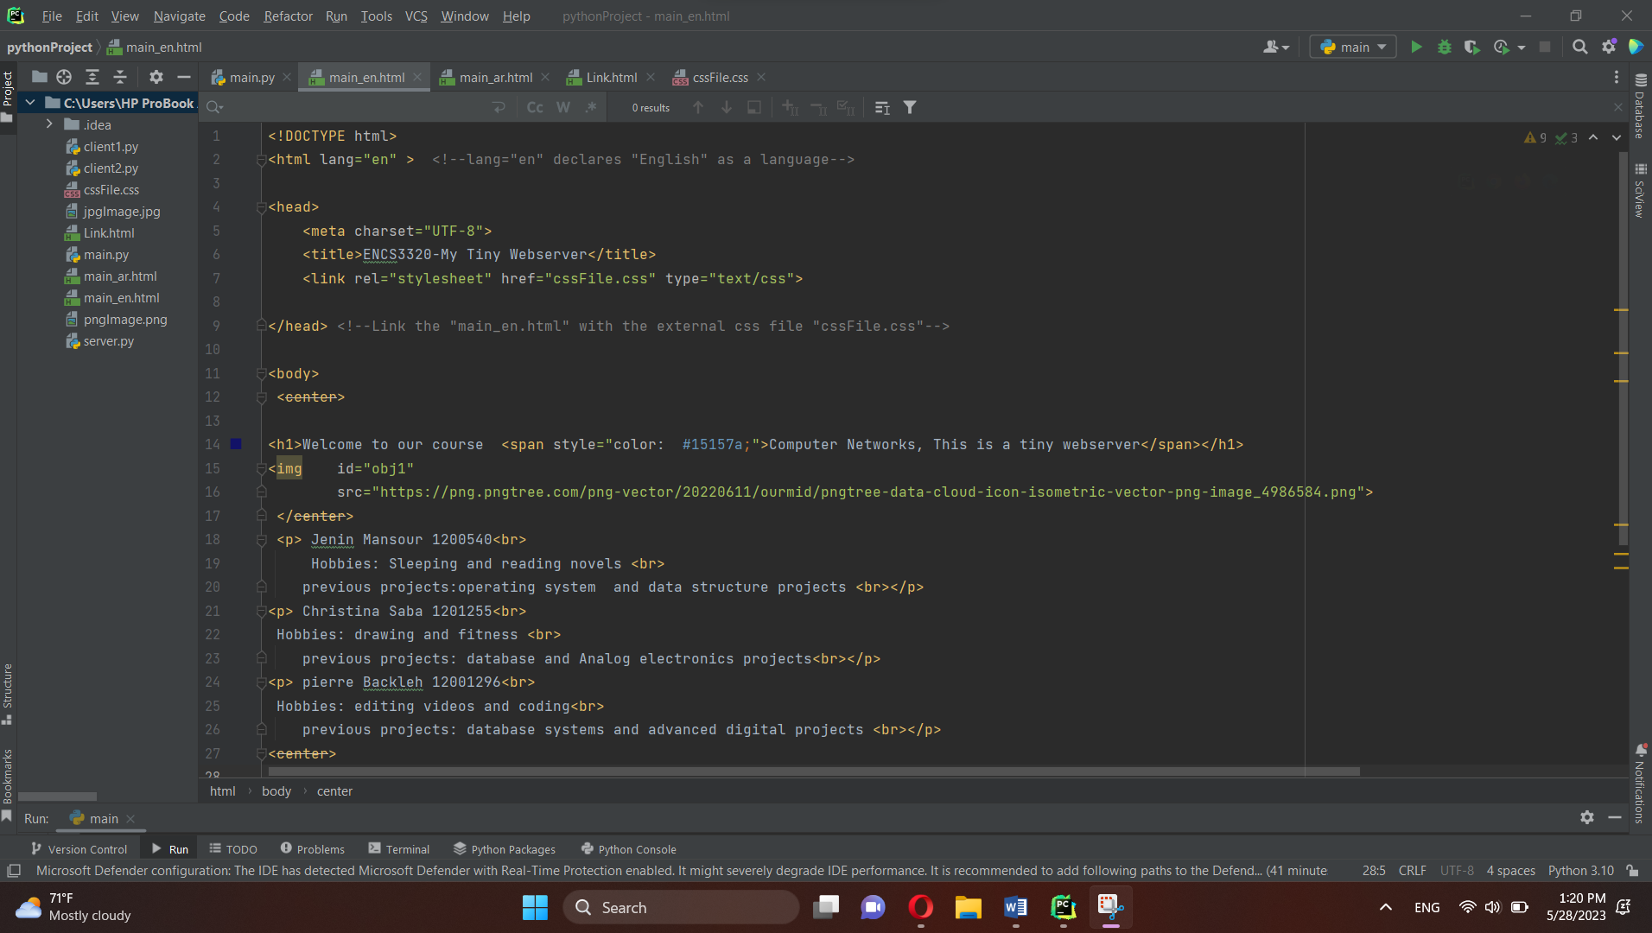

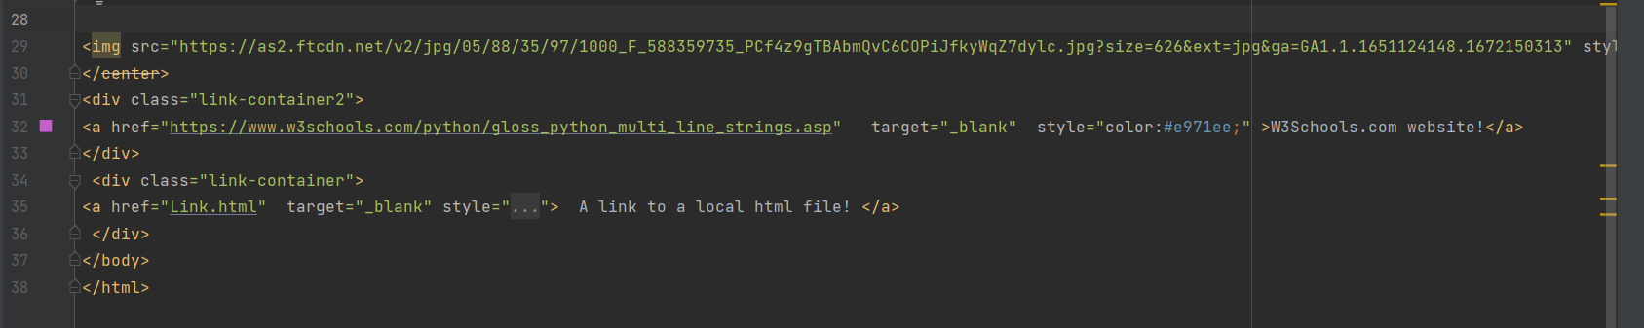

main_ar.html

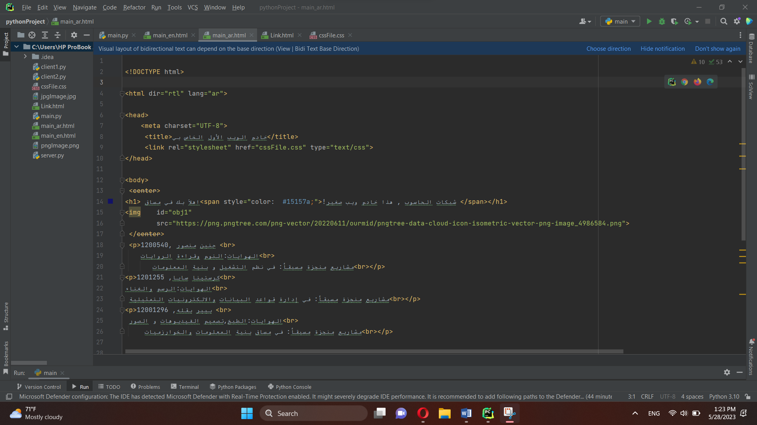

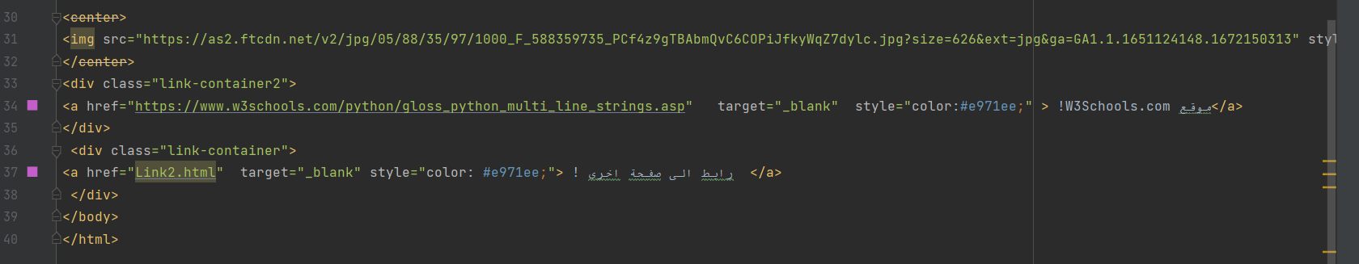

# Main.py code

from socket import *  
  
serverPort=9977 #Server port number to 7788  
serverSocket=socket(AF_INET, SOCK_STREAM) #creating a TCP socket for incoming request  
serverSocket.bind(("", serverPort)) #associate the server port number "serverPort" with this socket  
serverSocket.listen(1) #The server listen for TCP connection requests from the client with 1 queued connections.  
print("The web server is ready to receive!") #Print a message to tell the client that the server is ready to receive.  
while True:  
 connectionSocket, addr = serverSocket.accept() #When a client sends a TCP connection request create "connectionSocket" dedicated to this client  
 sentence = connectionSocket.recv(1024).decode()  
 print(addr)  
 print(sentence)  
 ip=addr[0]  
 port=addr[1]  
 request=sentence.split()[1] #Get the reqested object from client request massage  
 print(f"The HTTP request is: {request}") #print the HTTP request on the terminal window  
  
 if (request == '/' or request == '/index.html' or request == '/main_en.html' or request == '/en'):  
 connectionSocket.send("HTTP/1.1 200 OK \r\n".encode())  
 connectionSocket.send("Content-Type: text/html \r\n".encode())  
 connectionSocket.send("\r\n".encode())  
 fileminen=open("main_en.html", "rb")  
 connectionSocket.send(fileminen.read()) #read the file that was open when it called  
  
  
 elif (request == '/ar'):  
 connectionSocket.send("HTTP/1.1 200 OK \r\n".encode())  
 connectionSocket.send("Content-Type: text/html \r\n".encode())  
 connectionSocket.send("\r\n".encode())  
 filemainar=open("main_ar.html", "rb")  
 connectionSocket.send(filemainar.read())  
  
 elif (request.endswith('.html')):  
 connectionSocket.send("HTTP/1.1 200 OK \r\n".encode())  
 connectionSocket.send("Content-Type: text/html \r\n".encode())  
 connectionSocket.send("\r\n".encode())  
 filelink=open("Link.html", "rb")  
 connectionSocket.send(filelink.read())  
  
 elif (request.endswith('.css')):  
 connectionSocket.send("HTTP/1.1 200 OK \r\n".encode())  
 connectionSocket.send("Content-Type: text/css \r\n".encode())  
 connectionSocket.send("\r\n".encode())  
 filecss = open("cssFile.css", "rb")  
 connectionSocket.send(filecss.read())  
  
 elif (request.endswith('.png')): # files with the extensions '.png' and '.jpg'.  
  
 connectionSocket.send("HTTP/1.1 200 OK \r\n".encode())  
 connectionSocket.send("Content-Type: image/png \r\n".encode())  
 connectionSocket.send("\r\n".encode())  
 filepngimg = open("pngImage.png", "rb")  
 connectionSocket.send(filepngimg.read())  
  
 elif (request.endswith('.jpg')):#The same process occurs for '.jpg' files,  
  
 connectionSocket.send("HTTP/1.1 200 OK \r\n".encode())  
 connectionSocket.send("Content-Type: image/jpeg \r\n".encode())  
 connectionSocket.send("\r\n".encode())  
 filejpgimg = open("jpgImage.jpg", "rb") #open the image with jpg extension.  
 connectionSocket.send(filejpgimg.read())  
  
 elif (request == '/yt'):  
 connectionSocket.send("HTTP/1.1 307 Temporary Redirect \r\n".encode())  
 connectionSocket.send("Content-Type: text/html \r\n".encode())  
 connectionSocket.send("Location: https://www.youtube.com/watch?v=IAlRyJjTBIk&list=RDIAlRyJjTBIk&start_radio=1 \r\n".encode())  
 connectionSocket.send("\r\n".encode())  
  
 elif (request == '/so'):  
  
 connectionSocket.send("HTTP/1.1 307 Temporary Redirect \r\n".encode())  
 connectionSocket.send("Content-Type: text/html \r\n".encode())  
 connectionSocket.send("Location: https://stackoverflow.com \r\n".encode())  
 connectionSocket.send("\r\n".encode())  
  
 elif (request == '/rt'):  
 connectionSocket.send("HTTP/1.1 307 Temporary Redirect \r\n".encode()) #HTTP response to the client with a "307 Temporary Redirect" status code  
 connectionSocket.send("Content-Type: text/html \r\n".encode())  
 connectionSocket.send("Location: https://www.birzeit.edu/en \r\n".encode())  
 connectionSocket.send("\r\n".encode())

else: #scenario where a requested resource is not found by a client.  
 connectionSocket.send("HTTP/1.1 404 Not Found \r\n".encode())  
 connectionSocket.send("Content-Type: text/html \r\n".encode())  
 connectionSocket.send("\r\n".encode())  
 notFoundHtmlString = "<html>" \  
 "<head>" \  
 "<title>ERROR 404 </title>" \  
 "</head>" \  
 "<div>" \  
 "Error HTTP/1.1 404 the requested resource is not found<hr>" \  
 "<p style ='font-size: 45px; text-align:center; color:Red'>" \  
 "<strong>" \  
 "<strong>"\  
 "The file is not found </strong> </p>"\  
 "<pre style ='font-size: 25px; text-align:center; color: Black'> <br>"\  
 "<b> Jenin Mansour 1200540 <br/>"\  
 " Christina Saba 1201255 <br/>" \  
 "pierre Backleh 12001296 <br/><br/><br/>" \  
 "</b>" \  
 "</pre>" \  
 "<pre style='font-size: 25px; text-align:center;'>" \  
 f"The IP is: {ip} " \  
 f"The port is: {port}" \  
 "</pre>" \  
 "</div>" \  
 "</body>" \  
 "</html>"  
 notFoundHtmlBytes = bytes(notFoundHtmlString, "UTF-8")  
 connectionSocket.send(notFoundHtmlBytes)  
  
connectionSocket.close() # close the connection